Stephen Ministry
Pat Bartee - Leader
One of our goals from the beginning of our training and ministry was to be available not only to members of our church but to the diverse community we serve. A year later, we can report that our first care receivers have been just that and represented the diversity of our community, four church members and two people from our greater community. We are pleased to offer ministry in Spanish as well as in English and our doors are open to all.

Listening to one another is the key that opens the door to change. Really hearing how someone else feels is a great starting point for much of the conflict, hurt, and anger in our families, friendships, workplaces, and communities. Stephen Ministers embrace this skill and welcome walking with people in turmoil. Contact Barrett or Pat Bartee - Stephen Leader.

https://www.presbyterianwomen.org/what_we_do/build-community/antiracism/

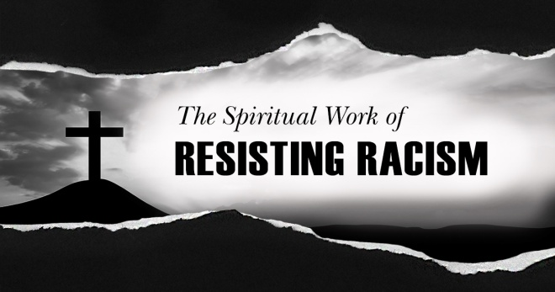
8-Day Racial Equity Education Challenge
Day 1: Visit and read the Racial Equity page of Presbyterian Women’s website. Then read PW’s statement on Racial Equity.
Day 2: Read the recommendations section on pages 21-23, located in the Structural Review of Presbyterian Women from an Antiracist Perspective: Report and Recommendations, approved by the voting representatives 2003 Churchwide Business Meeting.
Day 3: Watch the 2019 TED Talk by Baratunde Thurston on How to Deconstruct Racism, One Headline at a Time.
Day 4: Read the “Reflections on Radical Hospitality: A Supplement,” on pages 30-38 from Practicing God’s Radical Hospitality by Teresa Chavez Sauceda.
Day 5: Download and read The Belhar Confession.
Day 6: Commit to read one of the books from the Racial Equity Resource List found on the PW Racial Equity page.
Day 7: Host a watch party to view the documentary, 13th: From Slave to Criminal in One Amendment by Ava DuVernay, currently available on Netflix.
Day 8: Write a reflection of your thoughts and what you have learned about racism and racial equity. Commit to continue your racial equity education and invite a friend to complete this challenge.
https://www.presbyterianwomen.org/what_we_do/work-for-justice/racism/
PRESBYTERIAN WOMEN

POWERFUL KNOWLEDGE
TO
EMPOWER WOMEN

SUMMER QUARTER 2020
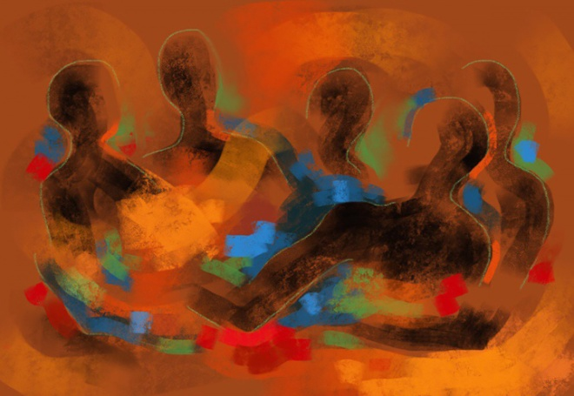

Beloved Conversations:
Meditations on Race and Ethnicity
Meadville Lombard Theological School

The Belhar Confession grew out of a need to declare apartheid in South Africa as antithetical to Christian principles. This stance reveals a positive attribute and declares unity and reconciliation in Christ. In our current days of protest and reevaluation, believers once again need to revisit God's Word and reexamine our own hearts as we move ahead.

https://www.presbyterianmission.org/resource/belhar-confession/

Mount Vernon Presbyterian Church
471 Mt. Vernon Hwy, NE
Sandy Springs, GA 30328
404-255-2211
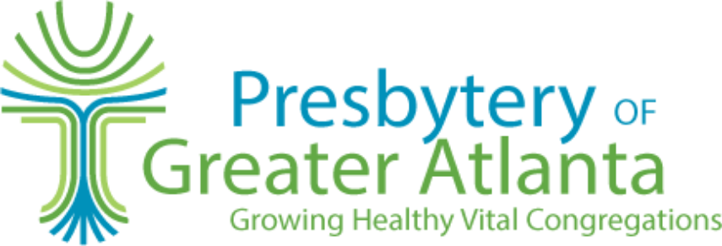
http://www.atlpcusa.org/pw.html
Summer 2020 MVPC Quarterly
Moderator Report – Sarah Chalpan
Our PW has planned and delivered two meals at two different times to Clifton Sanctuary Ministries, a shelter for homeless men in Atlanta, GA.

Our PW Coordinating Team has been able to conduct our monthly meetings for April, May and June through the Zoom platform.

Our Day Circles were not able to meet for April or May but are continuing to read and give thought to our lessons from our Horizons Bible study “Love Carved in Stone”.

Our Book Circle reviewed books in April and May via Zoom.

We do have a retreat planned for October entitled "Using Your Gifts" (At Any Age) Mazi Robinson will be our speaker. It will be at Lost Corner Preserve in Sandy Springs on October 4 beginning at 12:30. We, of course, do not know yet if this will actually take place, but we are planning accordingly. More information to follow.

Our Bible Study this year will be a continuation of last year's Horizons Bible Study "Love Carved in Stone". We did not have the last two lessons for April & May plus there were 4 more lessons we did not plan to discuss. But now we will.

Our 2020-2021 Slate of Officers
Moderator, Ann Williams
Vice Moderator, Joan Rownd
Past Moderator, Sarah Chalpan
Secretary, Gail Williams
Treasurer, Beppie Lever
Spiritual Growth, Linda Bhame
Resource Development, Clarice Elder
Community Missions, Pat Davis
World Missions, Marguerite Nelson
Publicity, Jeanne Gilliland
Search Committee, Pearl Attaway, Iva Corbin, Jeanne Gilliland
Day Circle, Malinda Holmes, Anne Baynham
Book Circle, Clarice Elder
Sunday Circle, Pat Davis
Circle of Grace, Shelly Ray

https://www.presbyterianwomen.org/2020/06/05/say-their-names-reaffirming-presbyterian-womens-stance-against-racism/

Updated 01/30/20
RACIAL EQUITY RESOURCE LIST
Are you searching for resources on antiracism education?
Presbyterian Women’s Racial Equity Committee (REC) has recommendations!

13th: From Slave to Criminal in One Amendment (Documentary) by Ava DuVernay; available on Netflix
Anxious to Talk About It: Helping White Christians Talk Faithfully about Racism by Carolyn B. Helsel
Bright Lights, Dark Nights by Stephen Emond
The Color of Law: A Forgotten History of How Our Government Segregated America by Richard Rothstein
Dear White Christians: For Those Still Longing for Racial Reconciliation by Jennifer Harvey
Decentering Whiteness in a Multiracial Society (Horizons Sept/Oct 2019 article) by Stephanie M. Patterson
How to Deconstruct Racism, One Headline at a Time (TED Talk 2019) by Baratunde Thurston
Into White (fiction novel) by Randi Pink
The Myth of Equality: Uncovering the Roots of Injustice and Privilege by Ken Wytsma
Neither Wolf Nor Dog by Kent Nerburn
So You Want to Talk About Race by Ijeoma Oluo
Stamped from the Beginning: The Definitive History of Racist Ideas in America by Ibram X. Kendi
How to Be an Antiracist by Ibram X. Kendi
The Tears We Cannot Stop by Michael E. Dyson
Uprooting Racism: How White People Can Work for Racial Justice by Paul Kivel
Waking Up White, and Finding Myself in the Story of Race by Debby Irving
White Flour by David LaMotte, illustrated by Jenn Hales
White Fragility: Why It’s So Hard for White People to Talk About Racism by Robin J. DiAngelo
White Rage: The Unspoken Truth of Our Racial Divide by Carol Anderson, Ph.D.

