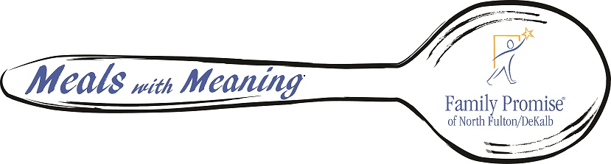 **2019 Sponsorship Packet**

Greetings,

Family Promise of North Fulton/DeKalb believes that every family deserves to live a life filled with hope and opportunity. In 2018, Family Promise of North Fulton/DeKalb celebrated 5 years of servicing the community and providing families with a safe, encouraging and educational environment. It is here that they receive shelter, meals and support services. We created programs for housing, homelessness prevention, life skills and mentoring so that they can achieve their maximum potential.

To continue to support this work and build awareness for what is being done, Family Promise of North Fulton/DeKalb will host a **Meals with Meaning** event on **Thursday, March 21st** 2019. This event is designed to build our community presence, increase the amount of volunteers that interact and assist in the well-being of our families and provide opportunities for individuals to get involved in their own backyards…literally!

Please consider joining Family Promise of North Fulton/DeKalb as a sponsor for our 2019 Meals with Meaning Event. There are several sponsorship opportunities available to assist with the success of this event. Your financial support not only underwrites the costs of the event, but will also invest in the lives of the families served throughout our communities.

The following documents include additional information regarding the purpose of the Event, Sponsorship, and Information on Family Promise of North Fulton/DeKalb.

Please take some time to read through this information, complete the enclosed Sponsorship Form and return to our office to become a partner in supporting the families that are in need in our communities.

Forms can be returned to Andrea Brantley at [director@familypromisenfd.org](mailto:director@familypromisenfd.org) or to Family Promise NFD

1978 Mount Vernon Road Dunwoody 30338.

Thank you in advance for your support of our mission.

With gratitude,

Andrea Brantley Sarah Caverhill

Executive Director Chairman of the Board of Trustees

Family Promise of North Fulton/DeKalb Family Promise of North Fulton/DeKalb

[*www.familypromisenfd.org*](http://www.familypromisenfd.org)

*770.609.5407*



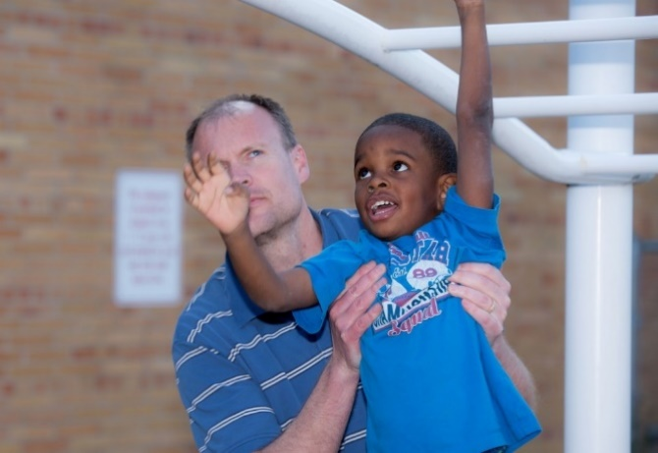

“The golden way is to be friends with the world and to regard the whole human family as one”

***- Mahatma Gandhi***

## Meals with Meaning Event

**Thursday, March 21st, 2019 Heritage Sandy Springs 6:00PM – 9:00PM**

***We invite you to join us for a southern style dinner served with wine, beer and iced tea.***

***Live music, 50/50 raffle and an inspiring testimonial from a graduate family***

***Opportunities to support our “Freedom to Work Program”***

|  |  |
| --- | --- |
| *“Wine and Dine” Level - $ 1000*  * Reserved Seating * Eight tickets to the event * Logo on program and video loop * Verbal recognition at the event * Logo and recognition on social media and FP Website | *“Soiree” Level- $500*  * Reserved Seating * Six tickets to the event * Logo on program and video loop * Verbal recognition at the event * Logo and recognition on social media and FP Website |
| *“Let Me Entertain You” Level - $300*  * Four tickets to the event * Logo on program and video loop * Verbal recognition at the event * Logo and recognition on social media and FP Website | *“Festivity” Level - $150*  * One ticket to the event * Logo on program and video loop * Verbal recognition at the event * Logo and recognition on social media and FP Website |





# Sponsorship Registration Form

Name Company

Address City/State/Zip Phone _____________________________________________________________________ _____________

Email ________________________________________ ________________________________________

**Pay Online at www.familypromisenfd.org**

**Credit Card**

Charge Credit Card # _________________________________________________________________________ Amount of_____________

Amex Visa MC Expiration Date CVV _____

Signature ____________________________________________________________________________________________________

**Check:** A check made out to “Family Promise of North Fulton/DeKalb” is enclosed for the

Amount of $ Check # ______________________________________________

**Please submit completed form and company logo (if applicable) to:**

**Andrea Brantley**

[director@familypromisenfd.org](mailto:director@familypromisenfd.org)

**1978 Mt. Vernon Rd.**

**Dunwoody, GA 30338**